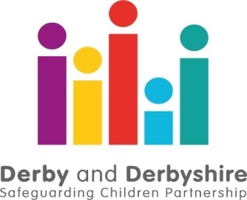

COVID 19 Performance Summary Briefing – Up to 31st December 2020.

The Derby and Derbyshire Safeguarding Children Partnership is working with all agencies involved in safeguarding children and young adults to understand the impact of the COVID19 pandemic and lockdown conditions. This includes where there is an anticipated increase in risks to children and young people because of the current situation, as well as how well agencies are working together to ensure at risk and vulnerable children are safe.

So far we can see that since the first lockdown period began on March 23rd 2020 up until the 31st December 2020...
Contacts and referrals from members of the public and professionals concerned about the welfare of a child or young person decreased sharply over the Christmas period but increased in the first week of January. If you are worried about a child or family, there are details here on how to get help. In an emergency, if you believe a child or adult is at immediate risk of serious harm, you should call 999 straight away and speak to the police.
The percentage of contacts that meet the threshold for referral remains comparable to those seen pre-lockdown. Work continues across the partnership to ensure that children and families are being helped at the earliest and most appropriate point for their needs.
Schools are now closed to the majority of pupils as a result of the third lockdown. Partnership agencies are working hard to ensure that those children that need extra support can access it, and that children are seen and are safe.
The high level of domestic abuse calls to the Police seen late last year has reduced. As with previous lockdowns this is expected to increase as restrictions ease. If you are worried about domestic abuse, there is further information on how you can get help here.
There has been an improvement in some of the waiting lists for children and young people waiting to access mental health support in Derby City and South Derbyshire, and waiting times for Core CAMHS in the North of the County remained stable in recent months, although a spike in Eating Disorders cases requiring urgent treatment has increased waiting times for these services in the North of the County. If you would like further information on available support, you can call the Mental Health Support line, details here.
There is evidence of an decrease in reported crimes relating to child sexual abuse, but a slight increase in the proportion of these crimes that have a familial link (where the perpetrator is a family member or would reasonably be viewed as one by the child or young person).
We will be reporting bi-monthly to the Chief Officer Group and further briefings will be provided to reflect the changing nature of performance data as a result of the impact of COVID-19.
Further information about local safeguarding processes is available from:

The Derby and Derbyshire Safeguarding Children Partnership Version: 01/02/2020

